# AMAZON ELASTIC COMPUTE CLOUD (EC2)

**To Launch EC2 Instance**

Compute EC2 Instance Launch Instance Name

# AMS’S [ Amazon Linux 2023] X86 (Architecture) Instance

# type:t2 micro (1 CPU & 1GB RAM) Key pair Name RSA

# Pem (open ssh ) Save

**Create an security group**

Security Create Security Group Name Description

# Inbound Add Rule (ssh 22) Anywhere (IPV4) Create

# Security Group

Under network setting Existing Security Group Select the security group Storage **{8GB Linux}** Launch Instance

# STEP 1:

# Navigate to EC2 Dashboard

# Log in to AWS Management Console

# Go to AWS Console.

# Enter your AWS account credentials and sign in.

# Ensure you're in the correct AWS region (e.g., US East (N. Virginia) us-east-1).

# 

# Open EC2 Service:

# In the AWS Console, click on 9 doted box, then select the compute services, and select EC2.

# 

# Instances and Launch instances

# This option allows you to create a new virtual server.

# 

# Configure EC2 Instance Details

# Instance Name: Enter a descriptive name for your instance. Ex: AWSoffline

# 

# Choose an Amazon Machine Image (AMI)

* Search for "Amazon Linux 2023"
* Select Amazon Linux 2023 (Free Tier Eligible).

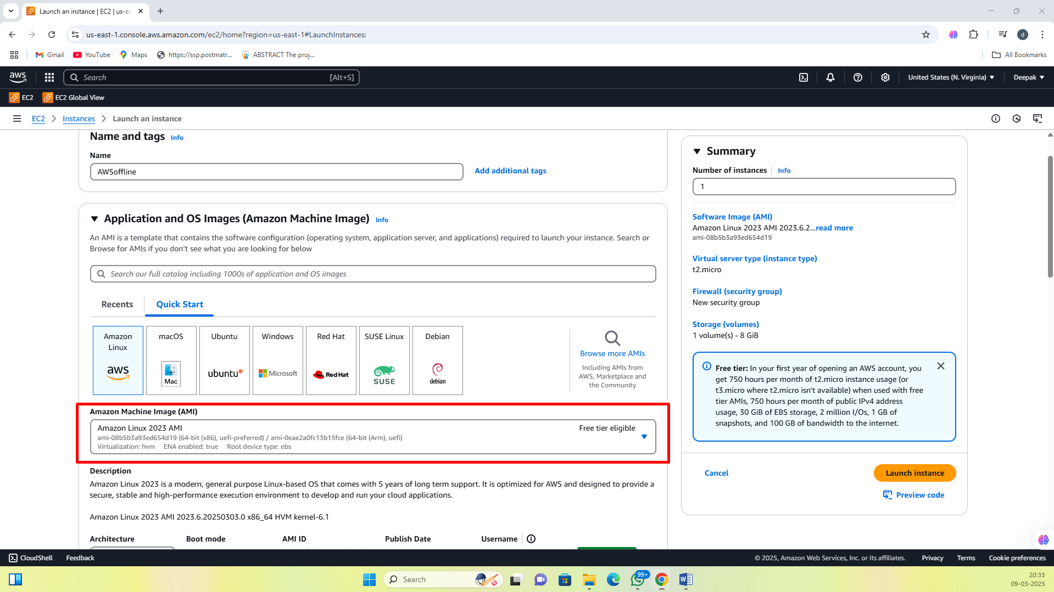

# Check the Architecture: x86_64 (for standard 64-bit processors).

# 

# Choose Instance Type

# Instance type determines the amount of CPU, RAM, and performance.

# Select t2.micro (Free Tier Eligible)

# CPUs: 1

# Memory (RAM): 1 GB

# Storage: EBS (Elastic Block Storage)

# 

# Configure Key Pair for Secure Access:

# A Key Pair is needed to securely connect to the EC2 instance using SSH.

# Click on "Create a new key pair"

# Key Pair Name: AWSoffline_keypair

# Key Type: RSA

# Format: .pem (For OpenSSH)

# Click Create Key Pair.

# Download the .pem file and store it securely (you will need it to connect via SSH).

# 

# 

# 

# 

# 

# STEP 2:

# Creating a New Security Group

# Open Security Group Settings

# On the "Launch Instance" Page, scroll down to Network Settings.

# 

# Select Create a New Security Group.

# Enter a descriptive name, e.g., ssh-security-group

# Description: Security group for SSH access to my EC2 instance

# 

# Add Inbound Rules

# Inbound rules allow external devices to connect to your instance.

# Click Add Rule.

# Type: SSH

# Port Range: 22 (default port for SSH)

# Source: Select Anywhere (0.0.0.0/0) to allow access from any IP address.

# Click Create Security Group.

# 

# 

# STEP 3:

# Configure Network & Storage

# Under Network Settings

# Select Existing Security Group.

# Choose the previously created ssh-security-group

# 

# 

# 

# Storage

# Default 8GB (for Amazon Linux).

# 

# Launch Instance

# Click Launch Instance

# 

# STEP 4:

# Connect to EC2 Instance

# Connect to instance , EC2 instance connect (Amazon Linux)

# With ec2 username and click connect

# 

# 

**Linux operations (inside AMI)**

1. To display the users 🡪 whoami

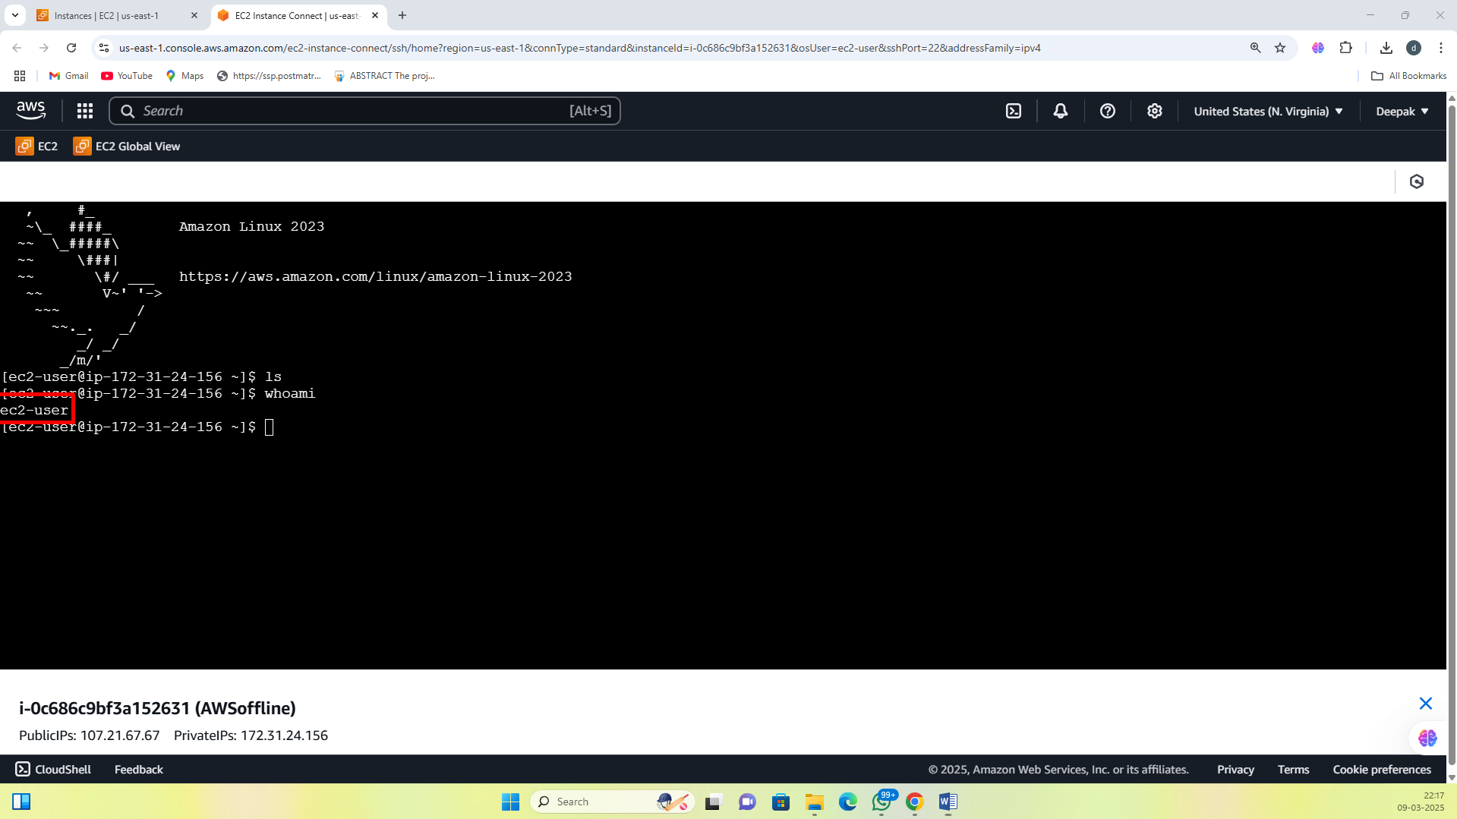

1. To get the path 🡪 pwd

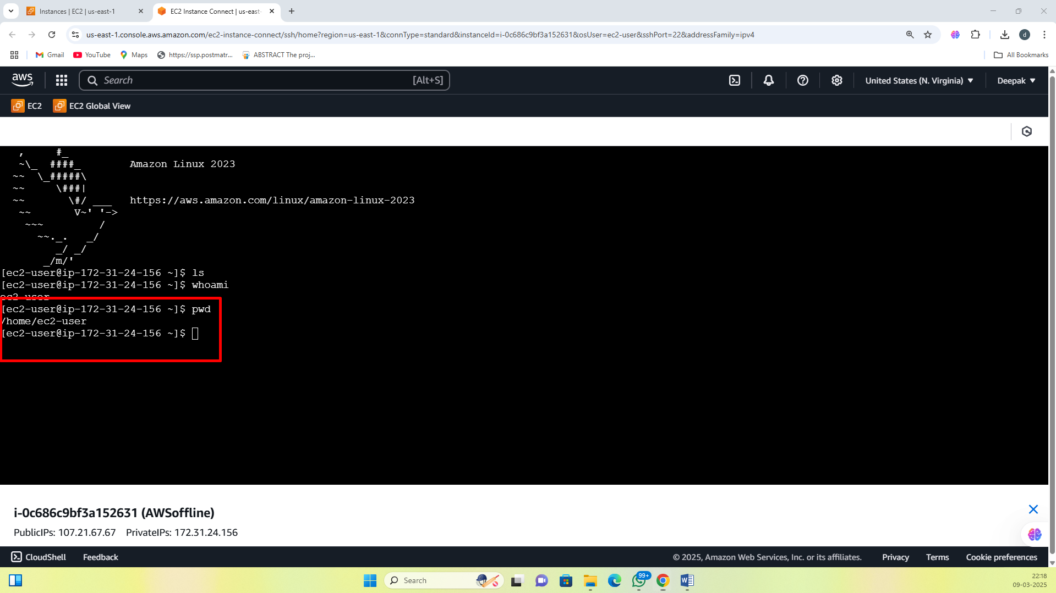

1. To create an directory 🡪 mkdir dir1

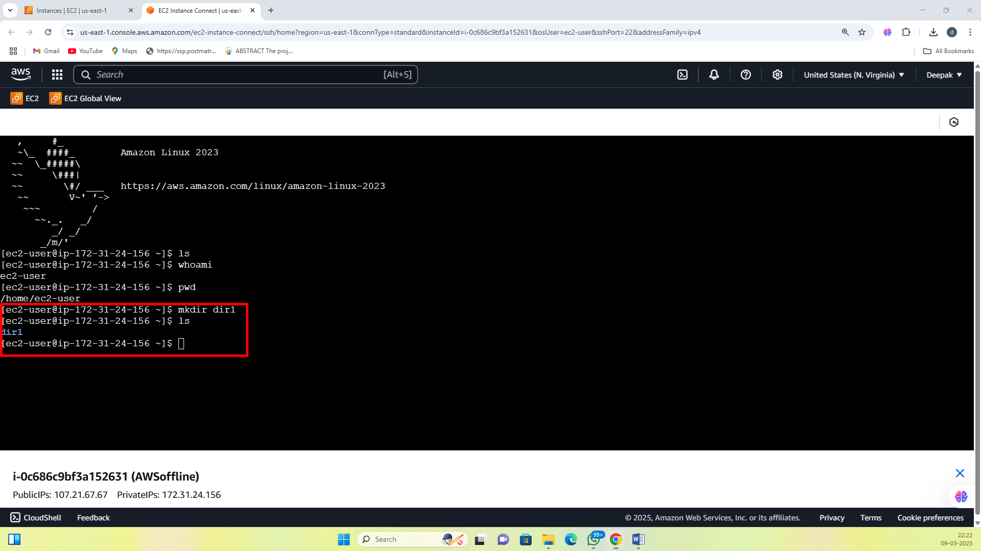

1. To enter inside the directory 🡪 cd dir1

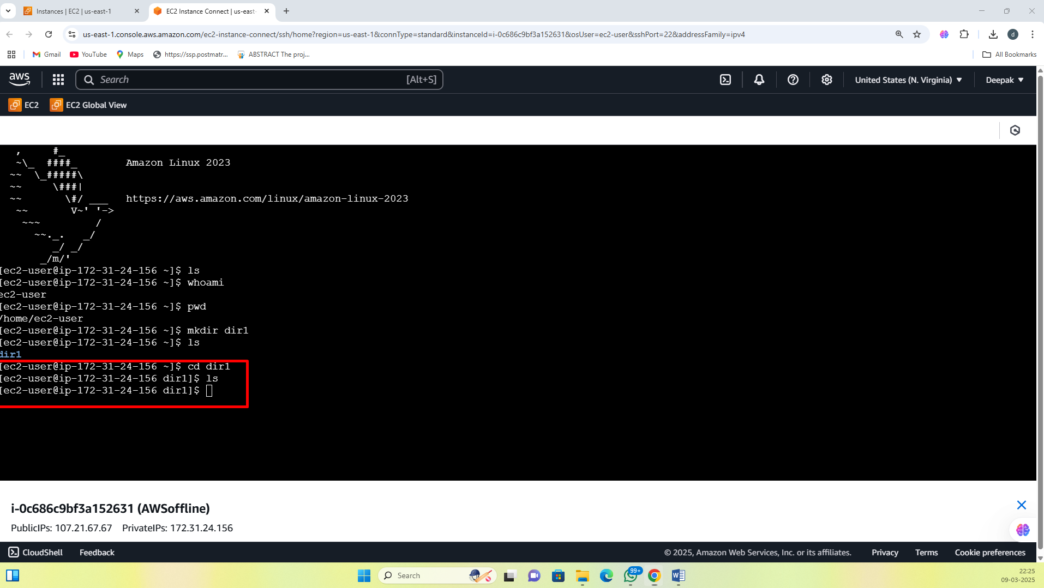

1. To create empty files inside dir1 🡪 touch file.text

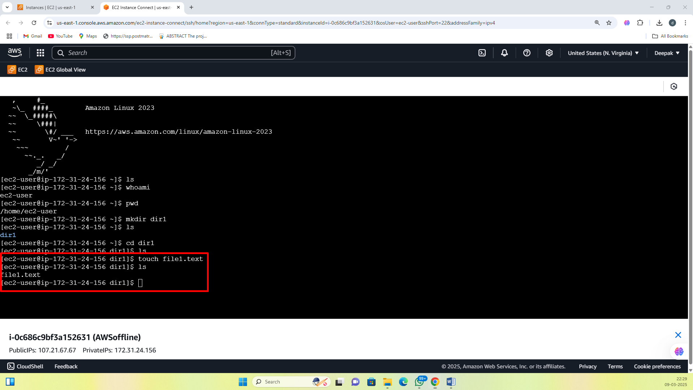

1. To edit the files (file editor) 🡪 nano file1.text (ctrl+s to save) (ctrl+x to exit)

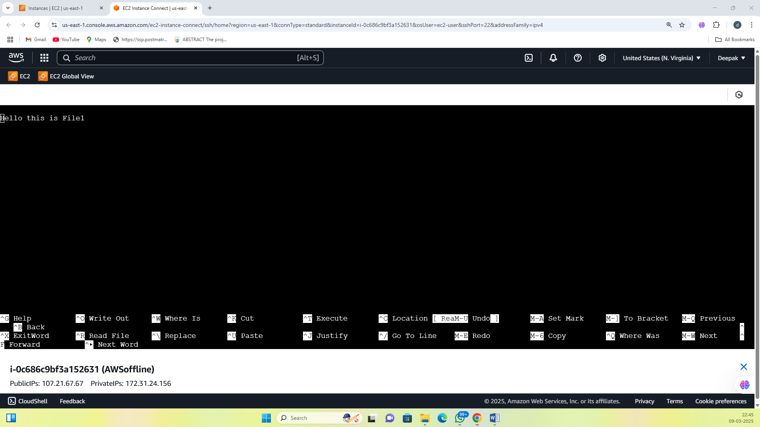

1. To command to display the contents of a file. 🡪 cat file1.text

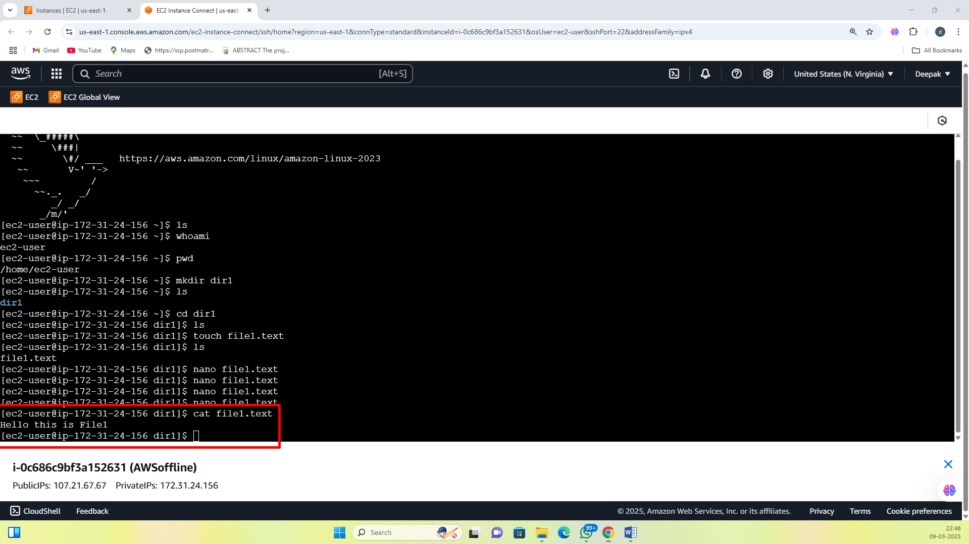

1. To create file 2 in dir1 🡪 nano file2.text

# 

# 

# 

# 

1. To exit from directory 🡪 cd ..

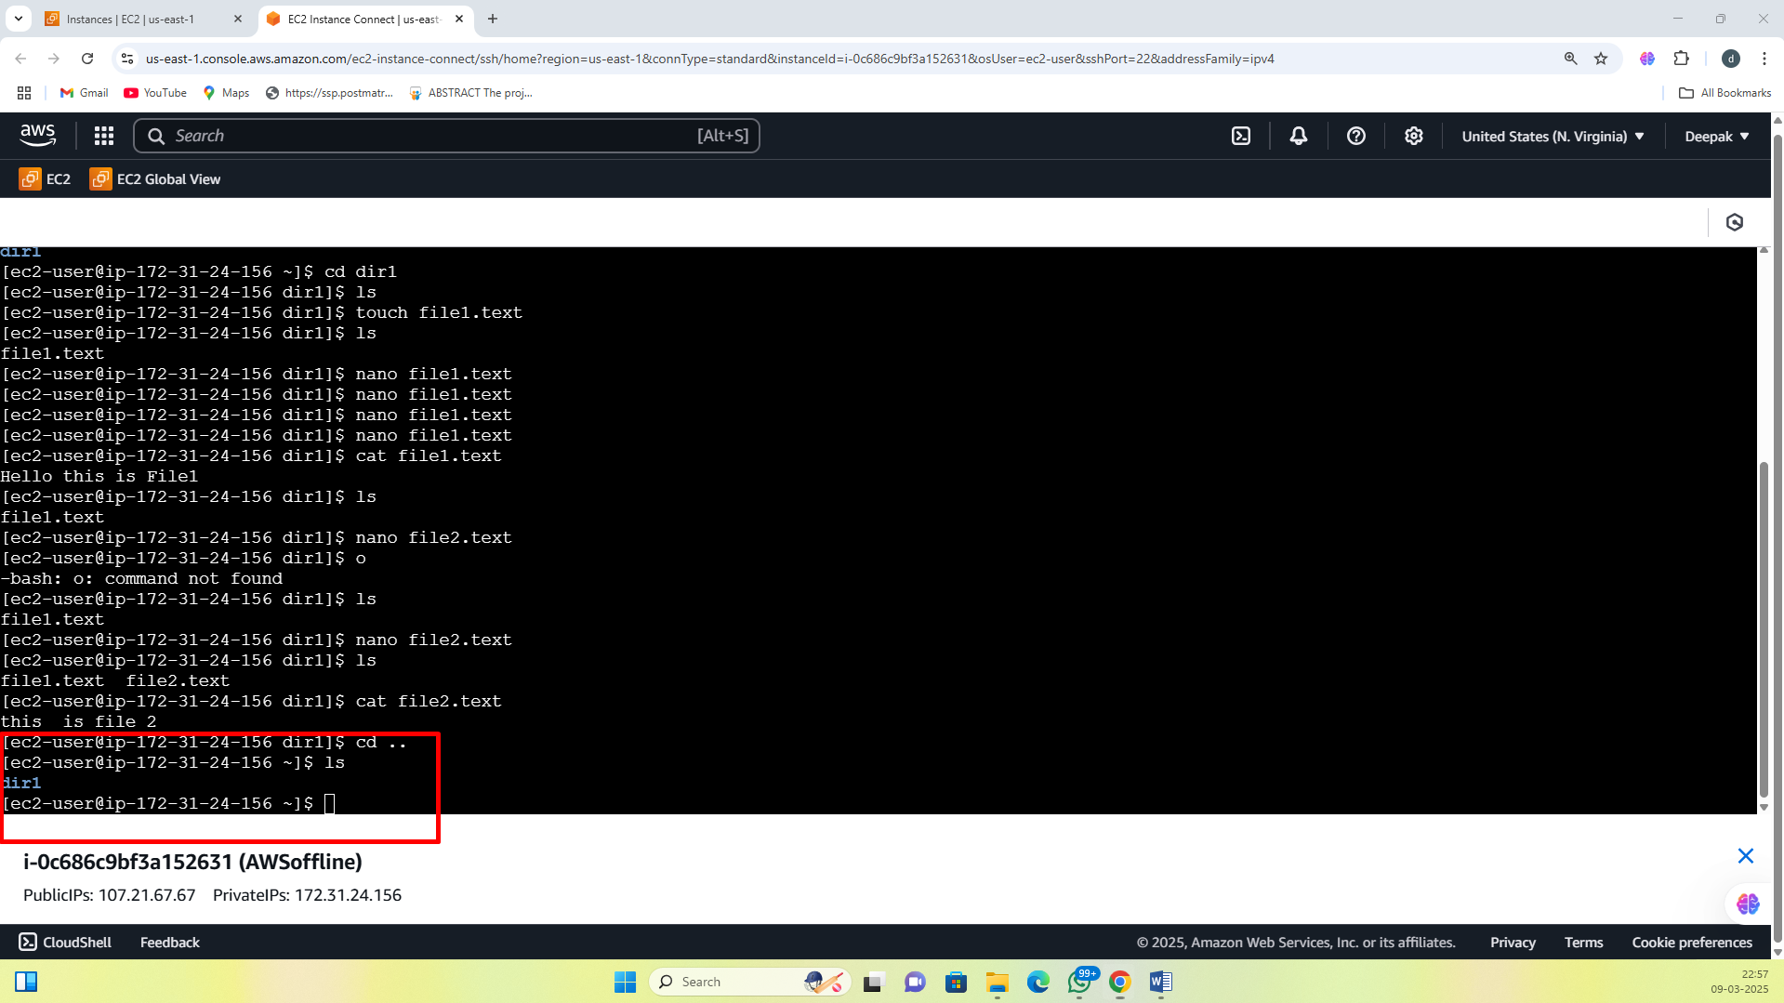

1. To switch to the root user 🡪 sudo su

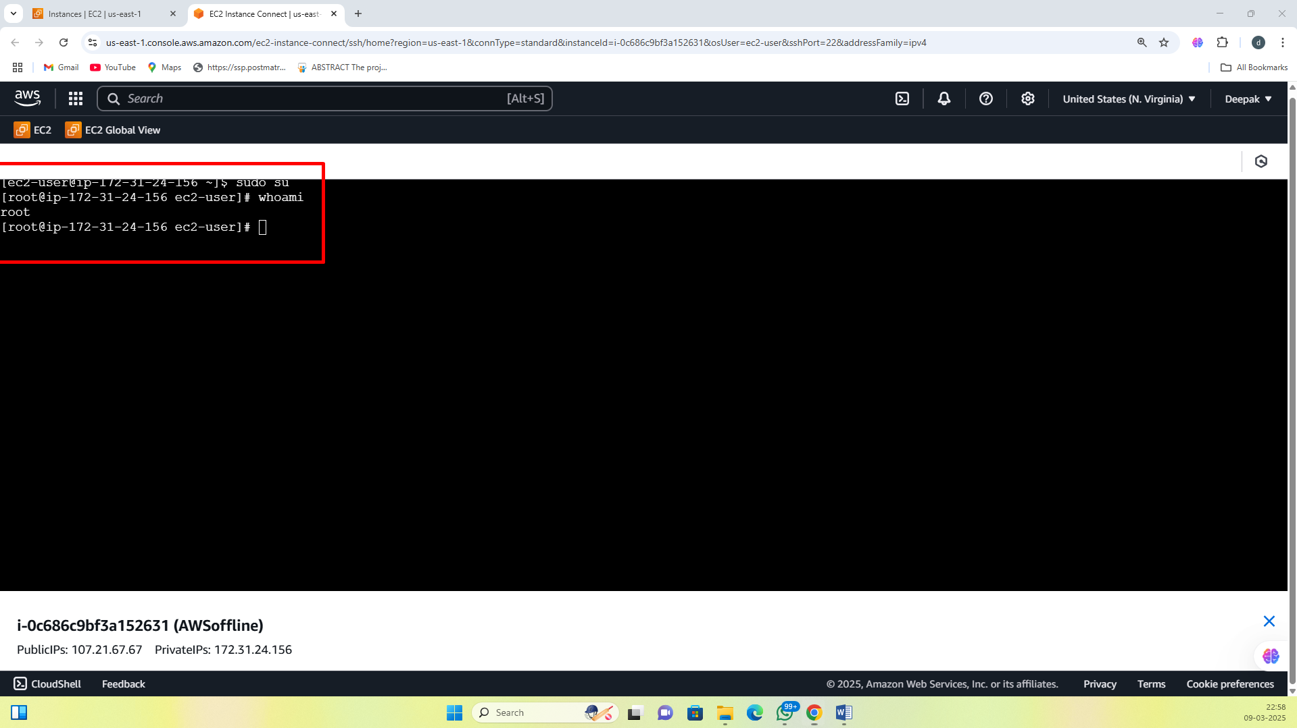

1. To install git 🡪 yum install git -y and to check version git --version

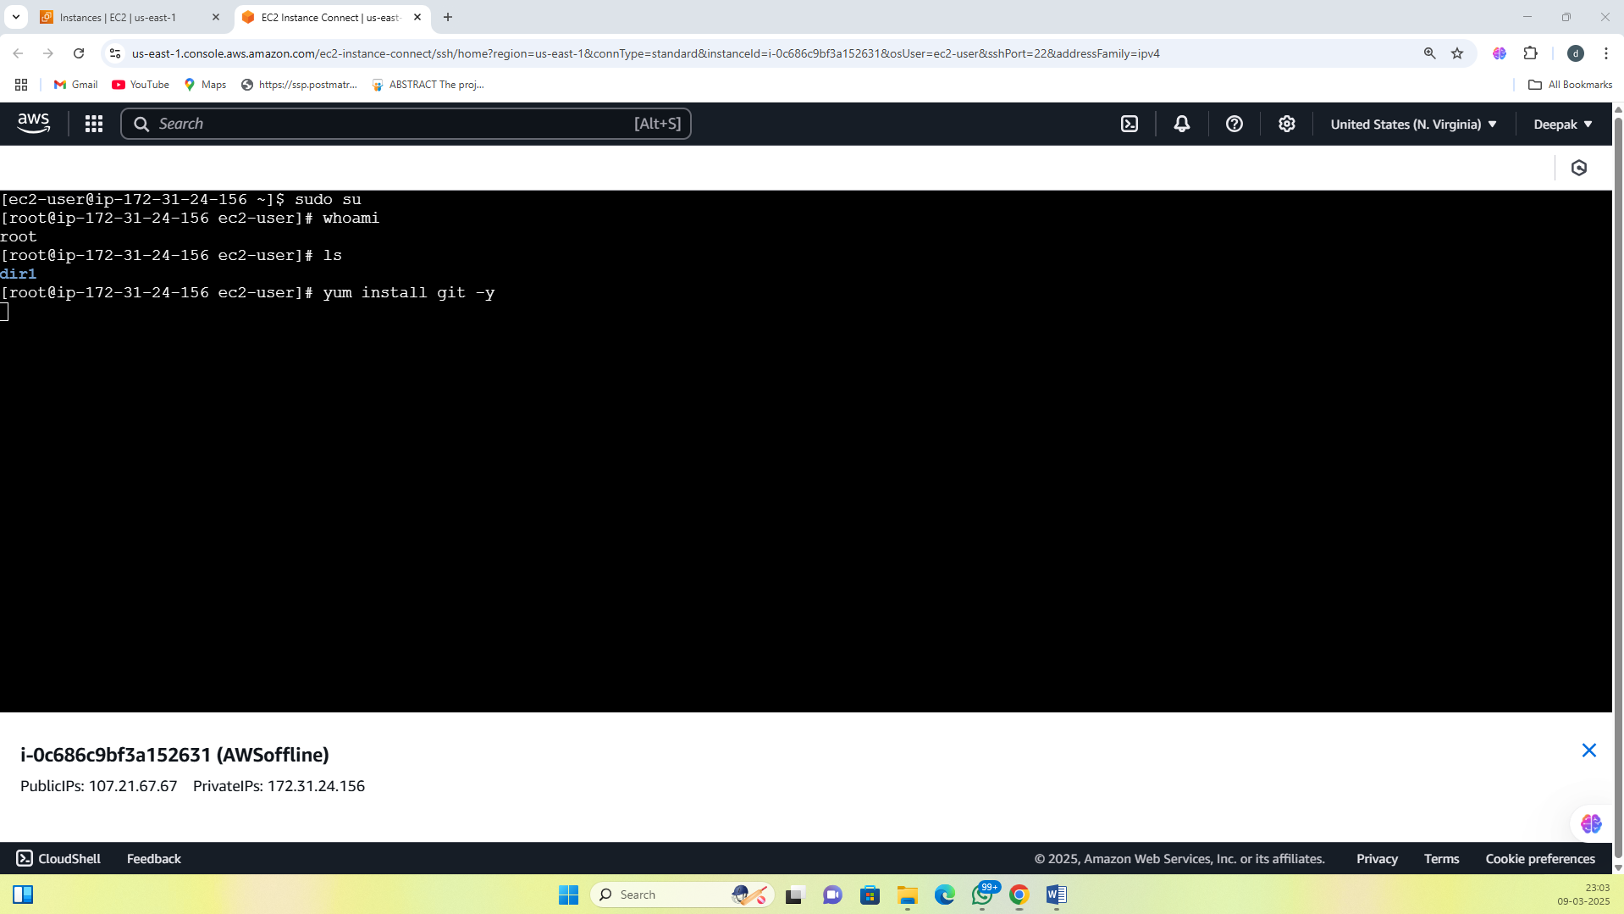

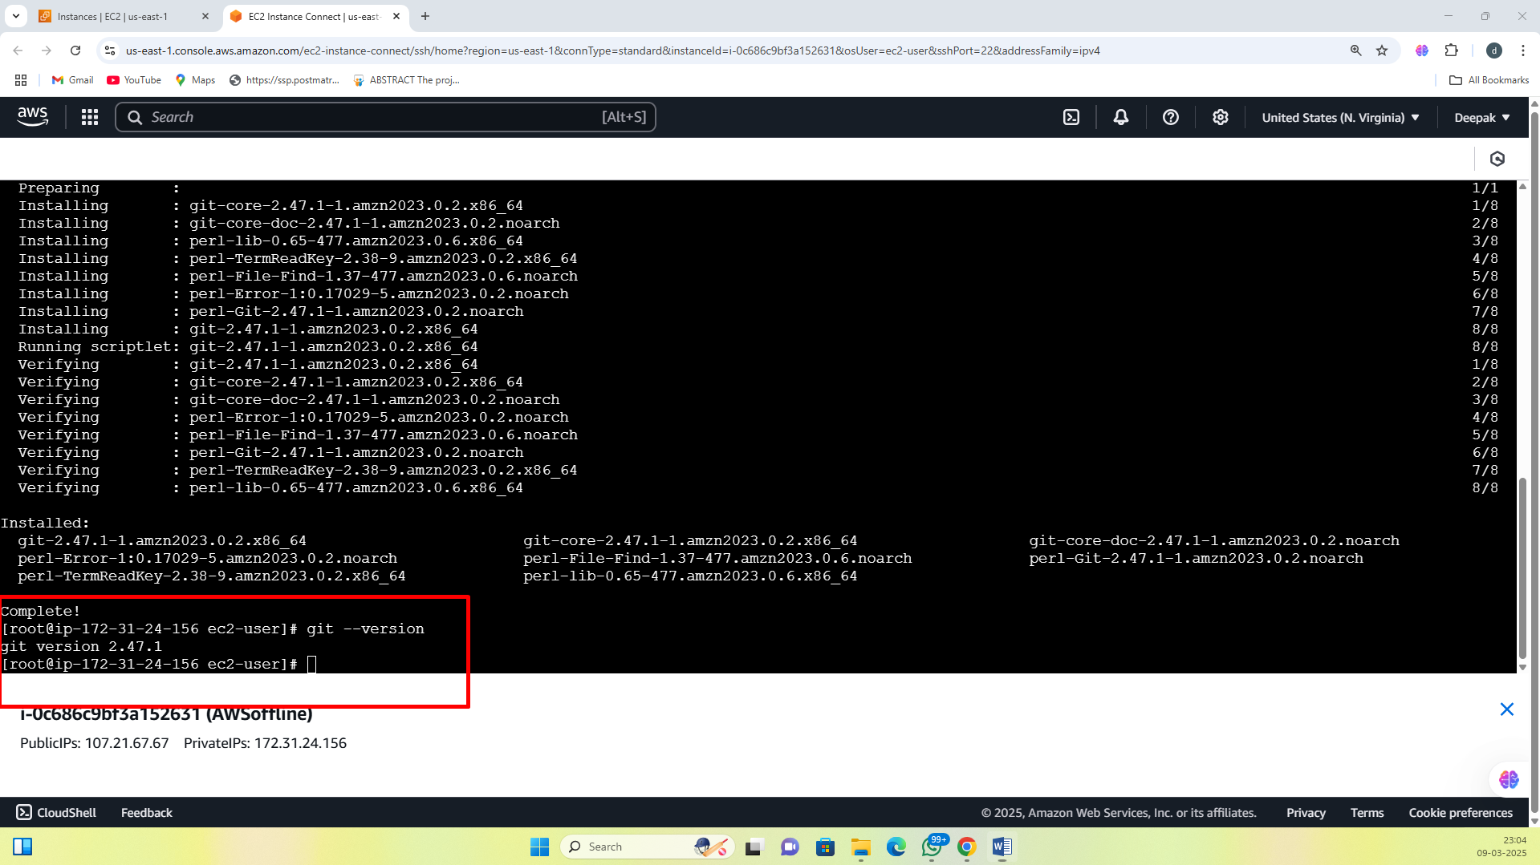

1. To install java 🡪 yum install java-17 -y and to check version java –version

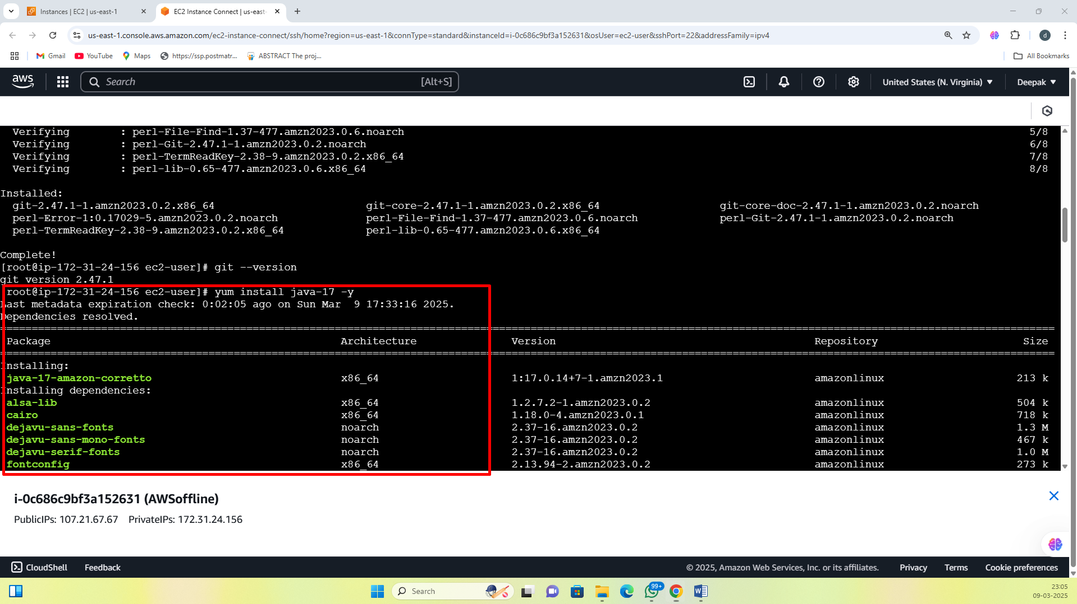

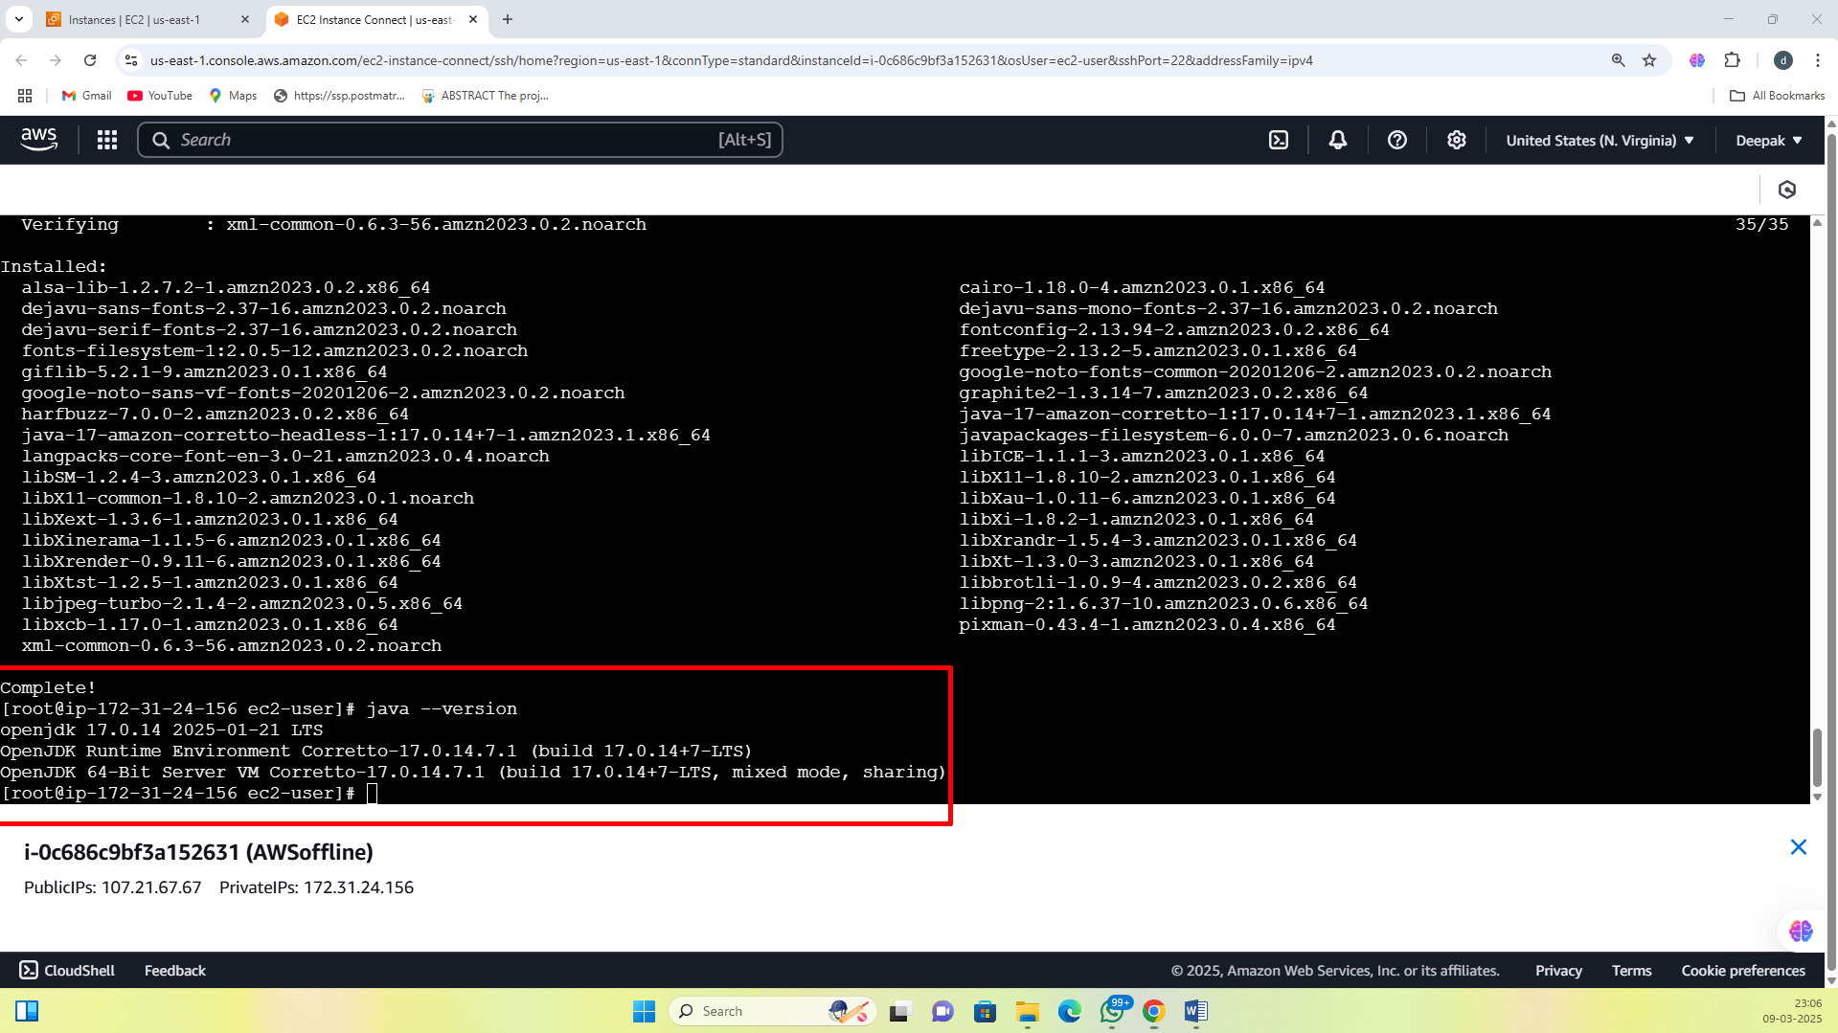

1. To create hello world program in java 🡪 nano Test.java , to run java Test.java

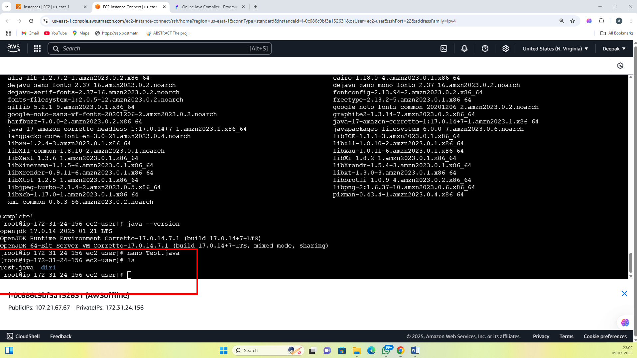

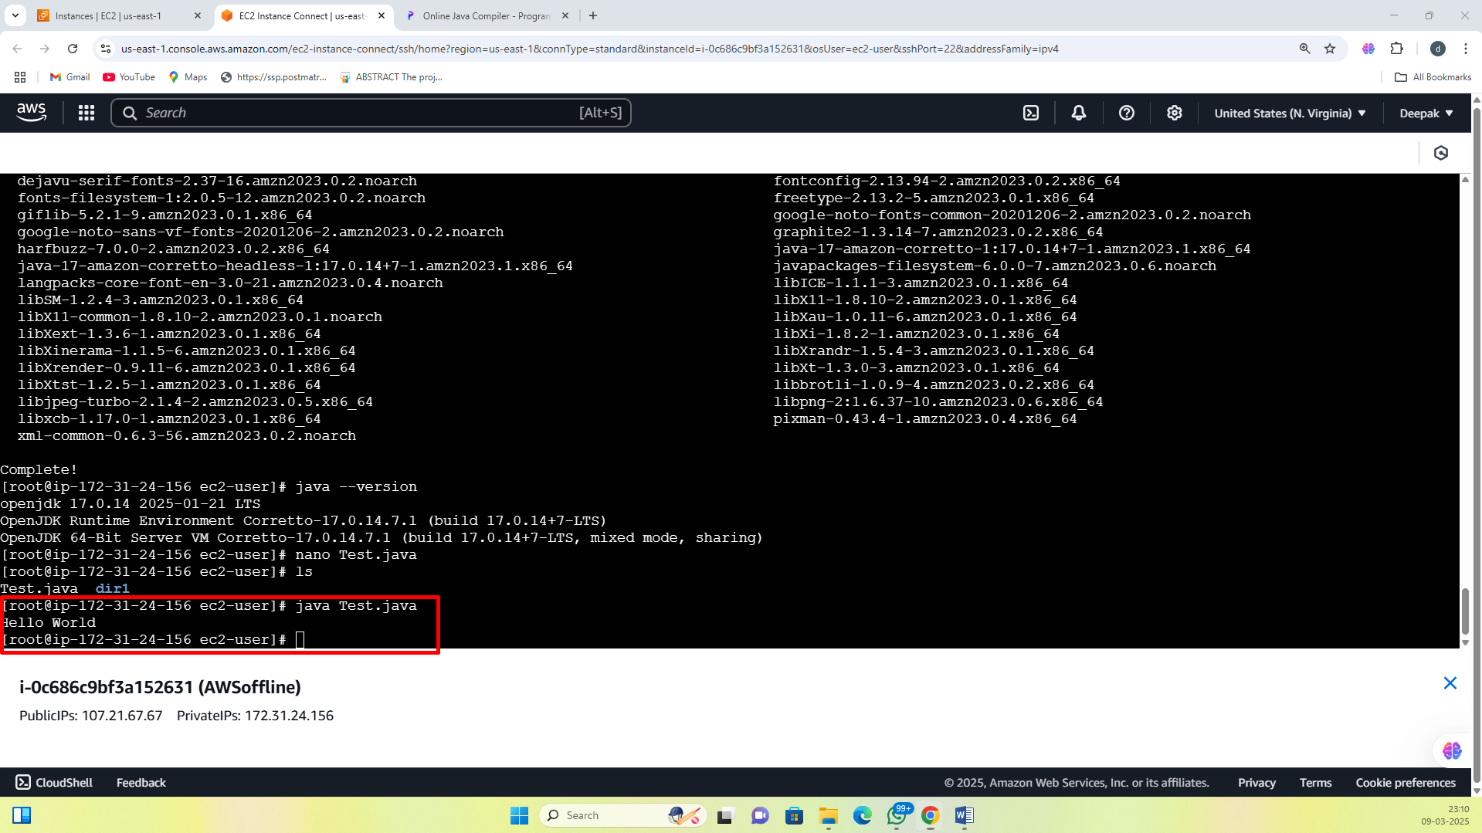

**Stop instance / terminate instance**

* Navigate to **EC2 Dashboard**.
* Click on **Instances** in the left panel.
* Select the instance you want to terminate
* Click on **Instance State** → **Terminate Instance**.
* Confirm by clicking **Terminate**.

